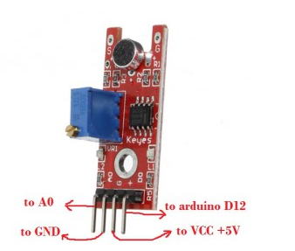
This project is to test Sound Sensor module. The sensor A0 pin will output analog sound value. the D0 pin will output HIGH voltage (1) if value over the threshold, otherwise export LOW (0). the threshold can be adjust by screwdriver.
Step 1: connect the sensor to Arduino as per following graph:
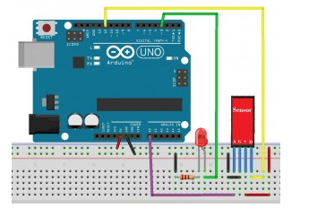
Step 2: Download sample sketch code and load it into Arduino IDE.
Step 3: click the serial monitor window, the monitor will show sound value as following:
